Adventist Single Adult Ministries Day
May 18, 2019
Material and resources for the local church

Mission Statement
Reaching and empowering Single Adults to create Christ-centered safe places for fellowship, nurture and service.

Table of Content

Suggested Order of Service 3

Author of the Children’s Story 4

Children’s Story 5

Author of the Sermon 6

Sermon 7

“The Single Focal Point”
Suggested Order of Service

Introit:

Opening Prayer:

Opening hymn: #330, “Take My Life and Let it Be”

Call for the offering:

Children’s Story: “The Focal Point”

Scripture: Responsive Reading #724, “O Lord, You Have Searched Me”

Sermon: “The Focal Point”

Closing hymn: #316, “Live Out Thy Life Within Me”

Author of the Children’s Story
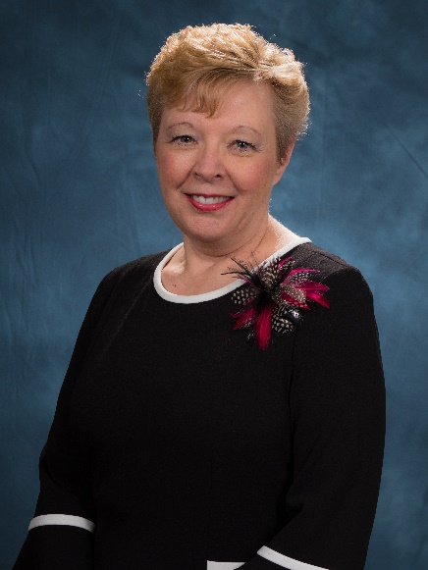
Dr. Pamela Consuegra is the Associate Director for Adventist Single Adult Ministries for the North American Division of Seventh-day Adventists. Her husband of over 30 years, Dr. Claudio Consuegra, was born in Colombia, South America, while Pamela grew up in the Appalachian Mountains of Virginia.
Pamela has a background in Adventist education, having served as a teacher, academy principal, and Superintendent of Schools. Pamela holds a Ph.D. in Leadership from Andrews University.
Together with her husband, Pamela has a rich background in the area of family ministries having worked as a husband and wife team in numerous conferences, hosting a live call-in family show for LifeTalk radio for three years, and authored numerous journal articles as well as several books.
They have two daughters: Diana, an English teacher at Takoma Adventist Academy, Hadassah, a resident surgeon in York, Pennsylvania, and a son-in-law, Greggory, who works as a Speech and Language Pathologist.

The Focal Point

Children’s Object Lesson

Preparation: If possible, use tape to mark off a straight line on the floor ahead of time.

Scripture: “Let your eyes look straight ahead, fix your gaze directly before you. Make level paths for your feet and take only ways that are firm. Do not swerve to the right or the left; keep your foot from evil.” Proverbs 4:25-27

Have you ever watched a gymnast walk on a balance beam? Did you notice how “focused” a gymnast appears during their balance beam routine. The gymnast looks straight ahead. They are taught to keep their eyes focused in front of them because if they look down, they fall.
Have you ever noticed how “focused” gymnasts appear when they perform a routine on a balance beam? They keep their attention fixed on a single point ahead of them.

I have marked off a line using tape here on the floor. Let’s pretend that this line is a balance beam. I know it’s on the floor but let’s just pretend it’s a high balance beam. Who wants to try to walk it? Hold your hands out to balance. Tell the children to try walking across the “beam” with their attention fixed on a focal point ahead. Let a couple of children attempt to walk the “balance beam”.

Questions for Discussion:
- What do you think would happen if a gymnast took their eyes off their focal point while they were on the beam?
- Where does the Bible say our focus should be? Do you remember the scripture verse we read at the beginning? Let’s read it again: “Let your eyes look straight ahead, fix your gaze directly before you. Make level paths for your feet and take only ways that are firm. Do not swerve to the right or the left; keep your foot from evil.” Proverbs 4:25-27

Yes, just like the gymnast needs to stay focused, we need to fix our focus on God, and on pleasing Him. When we keep our focus on God, it is much easier to follow Him. When we take our eyes off God, it becomes much more difficult to live in a way that pleases and honors Him.

Prayer:
Who would like to pray and ask Jesus to help us keep our eyes focused on Jesus?

Author
Pamela Consuegra, PhD
Associate Director
Adventist Single Adult Ministries
North American Division

Author of Sermon

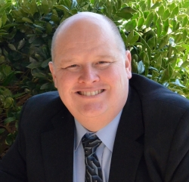
Dr. David Graham has pastored 11 years in the Carolina Conference and also serves currently as the Director of Adventist Community Services and Adult Singles Ministries.
Dr. Graham graduated from Southern Adventist University and Andrews University in Theology. He earned his Doctoral Degree in Ministry from Fuller Theological Seminary.
Previously, Dr. Graham served in the Florida Conference for 13 years as a pastor, Assistant Director of Men’s Ministry and has organized and lead regional ministerial associations.
Dr. Graham enjoys all forms of evangelism and working together with other ministries and missionaries activities.

The Single Focal Point
Message for Single Adults Sabbath
Pastor Dr. David Graham

What do these Bible names have in common?

Mary and Martha, Anna, Lydia, Samaritan Woman, Timothy, Titus, Mary Maggalene, Deborah, Hagar, Dinah, Miriam, Vashti, Naomi, Isaac till 40, the widow that served Elijah during the drought, Jeremiah, Ezekiel, Daniel, the prodigal son, the widow with her two mite offering? (pause)

Any thoughts? Yes, they are all - single. Singleness is Biblical. Single Adults that are often unmarried for seasons of their life or they are single their while lifetime.

This is a important detail that is often overlooked, our Christian faith is based upon a Jewish single adult from Galilee! Jesus Christ was Single. He was never married.

Also, John the Baptist was a single adult that announced and welcomed the ministry of Jesus.

God’s plan for His church includes the ministry of Adult singles.

What about this question? Who was the missionary that established the Christian church and wrote most of the New Testament of the Bible? Yes, the name of this single adult is none other than – the apostle Paul!

Singles that serve God in our church and community are a significant blessing.

They are a vital part of our spiritual family and God’s work.

Here is some of the Adult Singles
1) Young Adult Singles – Unmarried,
2) Single parents,
3) Widows,
4) Divorced / Separated,
5) Older Single Adults who never married.

Thank you to our Adult Singles that serve God in this church and are guests today!

Merriam-Webster Defines single - noun.
1: a separate individual person or thing
2: an unmarried person and/or especially one young and socially active - usually used in plural.

Transition: Today, the Bible will help us better understand that as separate individual people...

Main Point: ….We are to consider ourselves single spiritually
Complement: This spiritual singleness gives greater clarity and focus on God.

Illustration: Think of your hand (demonstrate – look at mine or yours) what do we call each of the fingers? Single digits. This indicates they are separate from the other fingers. We identify our toes the same way. They are separate but together. Recognizing our singularity is important for many reasons. We are all together here, Adult Singles, those married, families etc, We all follow Jesus individually and together.

Key Text: Luke 9:23
(NKJV) Then He said to them all, “If anyone desires to come after Me, let him deny himself, and take up his cross daily, and follow Me.

(NLT) Then he said to the crowd, “If any of you wants to be my follower, you must give up your own way, take up your cross daily, and follow me.

(NCV) Jesus said to all of them, “If people want to follow me, they must give up the things they want. They must be willing to give up their lives daily to follow me.

Transition: This is a bold and strong statement for all Christians. Jesus makes it very clear that personal individuality is important when following Him.

Jesus makes it clear that if we want to follow Him…

I. We are to be Single-minded for Jesus (Him)
Luke 9:23a “if any man will come after me”
- We have a choice to make. Literally, we all were born single and that we all are saved single. We did not have a choice to be born, just like many Single Adults do not choose to be single. That said, ALL OF US have the individual choice to follow the Jesus… every day! This decision is the single most important decision in life you can make.

- Single young people here today, it is important to make this decision to follow Jesus for yourself.

- Many people have difficulty deciding which way they will go. They some try to hold onto the world with one hand and the other hand on God. Sometimes a Christian can go for days not choosing to follow Jesus. When we do this, we are choosing to be alone. Jesus asks His disciples, he invites them to “come” and “follow” Him.

- Illustration: A farmer hired a man to work for him. He told him his first task would be to paint the barn and said it should take him about three days to complete. The man finished the job in one day. The farmer set him to cutting wood, telling him it would require about 4 days. The hired man finished in a day and a half, to the farmer’s amazement. The next task was to sort out a large pile of potatoes. He was to arrange them into three piles: seed potatoes, food for the hogs, and potatoes that were good enough to sell. The farmer said it was a small job and shouldn’t take long at all. At the end of the day the farmer came back and found the hired man had barely started. “What’s the matter here” the farmer asked. “I can work hard, but I can’t make decisions!” - Source Unknown

- Make decisions, smaller to larger decisions come as we grow up. It is so important to become a good decision maker. Illustration: Timeless chorus for so many. “I have decided to follow Jesus.”

Transition: Jesus makes it very clear that we must make a choice to following Him. We must be confident in our personal decision for Jesus. No one else makes this decision for you. The decision we make for Jesus gives us Singleness of mind and the heart will follow our choice.

II. We are to be Single-hearted for Jesus
Luke 9:23b “let him deny himself and take up His cross daily”

- Many people are devoted to their self-interest and self-indulgence. Giving Jesus 100% of your heart protects it and connects it Jesus. Many fail to give their whole heart to Jesus. Many fail practice self-denial and restraint daily. This is a struggle for everyone in differing areas of life. We must set certain boundaries for ourselves or Satan can hurt our heart. James 1:12 says, “Blessed is the man endures temptation.”
- Remember that we are taking up Christ’s cross. This is not your cross personally. You’re not alone in this. This is the Christ’s Cross!! He is with you every day. He is with you when you pray in the morning. He is with you when you go to work and school. He is with you when you come home, He is with you in a bad day! He is with when you feel defeated and alone! He is with you loving and sharing His love and help with others!
- Illustration: Henry Ford said, “A weakness of all human beings is trying to do too many things at once. That scatters effort and destroys direction. It makes for haste, and haste makes waste. So we do things all the wrong ways possible before we come to the right one. Then we think it is the best way because it works, and it was the only way left that we could see. Every now and then I wake up in the morning headed toward that finality, with a dozen things I want to do. I know I can’t do them all at once.” When asked what he did about that, Ford replied, “I go out and trot around the house. While I’m running off the excess energy that wants to do too much, my mind clears and I see what can be done and should be done first.” Bits and Pieces, September 19, 1991, p. 18

Transition: Jesus makes it very clear that it takes a definite decision to following Him and devoted dedication with our whole heart. This devotion gives a single focused walk with Jesus.

II. We are to be Single-Focused on Jesus – “and follow Me”

- Illustration: There is a law of physics that says that every circle has a focal point or a center. If you change the focal point you change the course of the circle. This law is also true in life. Each of us have some focal point. Everyone has some point of interest. If we make anyone of our interests or efforts the focal point our life can go in all different directions.

- (Demonstrate – OPTIONAL) The cross represents Christ’s, His love, forgiveness, sacrifice, loyalty and mission. The cross is the symbol of our salvation. When Jesus is the focal point of your life your circle of your reach includes all of life. List of the other things Christian’s pursue in life.
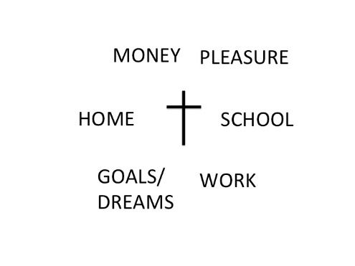
Your focal point will be that which is the greatest appeal to you. Whichever one you choose you move toward and it is your focus.

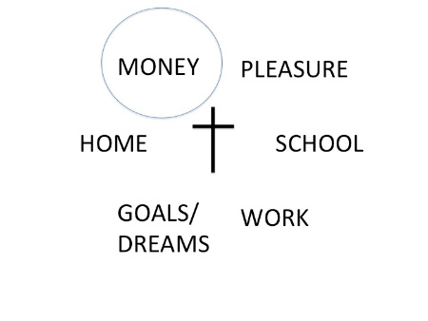
If money is the focal point of life then you will go toward the money. If Jesus is not the focal point of your life then you will not and cannot be begin with the cross.

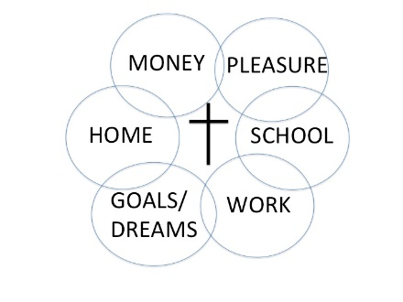
This is an illustration of someone not interested in following Jesus. You can go all these directions your focus away from Jesus. Whatever you want will become the focal point of your life and your circle.

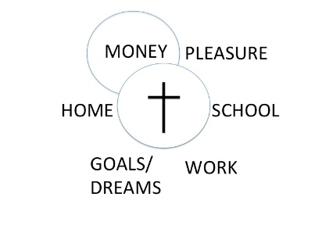
This is an illustration of a Christian that wants money as the focal point and Jesus too. Notice that the circle which has the cross is an unbroken circle and money is a broken circle. Jesus is the only circle that can make a personal whole.

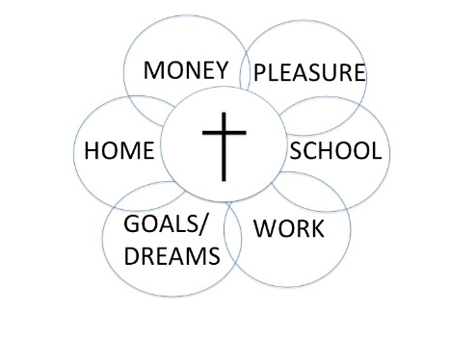
Notice if you put the focal point on any of the circles they are broken. They represent a life which wants the things of this world more than Jesus.

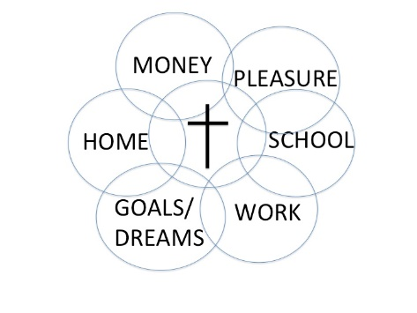
Notice what happens when you make Jesus the focal point of your life. When Jesus is the center circle and you following Him first and foremost, Jesus is part of everything. He helps you with everything! Your influence, your abilities, your challenges are together with Jesus. When Jesus is your focal point He brings everything together.

The illustration shows that when we are Single minded, hearted and focused on Jesus Christ, He brings everything together for our personal, individual and spiritual wellbeing.

Closing Illustration:
Dating back to 1955, Arnold Palmer is generally regarded as one of the greatest and most charismatic golf players in the sport's history. His wins were numerous which earned him the nicknamed, The King. Arnold Palmer recalls a lesson about overconfidence: It was the final hole of the 1961 Masters tournament, and I had a one-stroke lead and had just hit a very satisfying tee shot. I felt I was in pretty good shape. As I approached my ball, I saw an old friend standing at the edge of the gallery. He motioned me over, stuck out his hand and said, “Congratulations.” I took his hand and shook it, but as soon as I did, I knew I had lost my focus.
On my next two shots, I hit the ball into a sand trop, then put it over the edge of the green. I missed a putt and lost the Masters. You don’t forget a mistake like that; you just learn from it and become determined that you will never do that again. I haven’t in the 30 years since.
Carol Mann, The 19th Hole (Longmeadow), quoted in Reader’s Digest

Appeal: Make Jesus the Single most important focal point of your life. If you’re mind is wandering, If your heart’s desires are going another direction. Focus on Jesus and He will help you follow Him.

